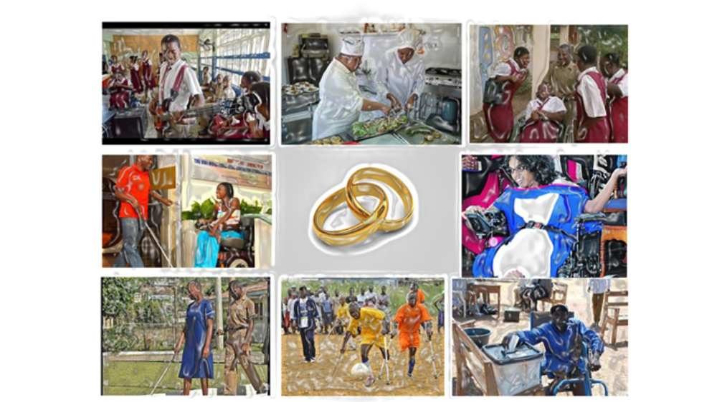

unicef/ministry of education transition initiative
This supplemental guide is to be used along with the Independent Development Partners (IDP) Training Manual and Toolkit for Secondary Schools.

Table of Contents
Content 4
School-to-Work Transition Planning 7
School-to-Work Transition Summary – Planning 8
What is transition planning? 8
The STWT Team 9
Transition Team Stakeholder Roles and Responsibilities 10
Considerations for the Learner 13
Considerations for Categories of Special Educational Need and Disability 14
Supporting learners with Learning Disabilities (LD) 14
Supporting student who are Gifted and Talented (GAT) 15
Supporting the learner with Emotional Behavioral Disorders (EBD) 16
Supporting the learner with Physical and Multiple Disabilities 17
Supporting students who are Deaf/Hard of Hearing 18
Supporting students who are Blind/Visually Impaired 19
Supporting students with Autism Spectrum Disorder (ASD) 20
Planning for the Learner 22
Setting the foundation for transition planning 22
Engaging the learner for transition planning 22
Engaging the family for transition planning 22
Evaluating the school support for transition planning 23
School-to-work Transition Preparation 24
The Transition Plan 25
Team Meetings 27
Critical steps for the Transition Team 28
Critical points to drive the discussion of the Transition Team 28
The Guidance Counsellor’s Role 29
Home and School Collaboration 29
School and Community Collaboration 30
Interagency Collaboration 30
Planning for the Student – Critical Considerations 32
Steps to planning 32
Incorporating Transition Plan into the Individualized Intervention Plan (IIP) 33
Steps to develop transition goals 35
What should the transition plan include? 35
Life-Centred Education Curriculum 35
Summarizing Comments 44
References 44

Figures

Figure 1 – UNICEF’s framework for skills necessary for STWT 4
Figure 2 – Stakeholder network 5
Figure 3 – Core skill-sets of school-based curricula 6
Figure 4 – The transition planning process 9
Figure 5 – Potential collaborative transition team stakeholders 10
Figure 6 – The action model for self-determination 25

Content
The content of this supplemental guide is taken mainly from the Situational Study conducted in 2022 by the Independent Development Partners (IDP). After an evaluative study of the Jamaican context for school-to-work transition (STWT), they provided a Toolkit that would guide the introductory and sustaining work of school-to-work transition activities in our local schools.
In its broad sense, the term ‘transition from school to work’ is used to refer to the general learning and preparatory activities for students leaving the secondary level of education, and how the curriculum prepares them for work and life after school. For learners with special educational needs and disabilities, the steps to prepare them for life beyond high school are more layered and complex. The category of disability, and the levels at which persons function will vary. The responses to support, and the services needed will differ also. To ensure youth in special education programs are prepared to transition into adult roles and responsibilities, more careful attention must be directed to the domains of development, and the linkages between academic and non-academic competencies. The UNICEF expectations for transition into the world or work for the general population of school-leaving youth are represented in Figure 1 below.

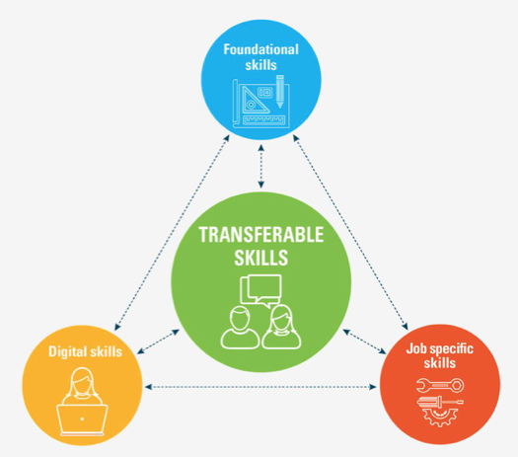
Figure 1. UNICEF’s framework for skills necessary for STWT
Source: Figure 1 - IDP Manual and Toolkit, p. 2
Source: IDP Manual and Toolkit, p. 2
The considerations for youth in special education programs may be guided by these main skill-expectations. The transition pathway, however, is broken out to include multiple steps to ensure the planned outcomes are accomplished.
The transition from school to work includes the school and family. Successful transition into the world of work involves other individuals, groups, agencies, and organizations. These stakeholders contribute to the activities that form the integrated transition program for youth preparing to leave school. The outcomes for job-skills development and work are possible with the help of the network of stakeholders summarized in Figure 2. The four (4) critical elements for transition planning are: collaboration between home and school collaboration among service agencies; practicing self-advocacy and having a supportive network; and mentorship.
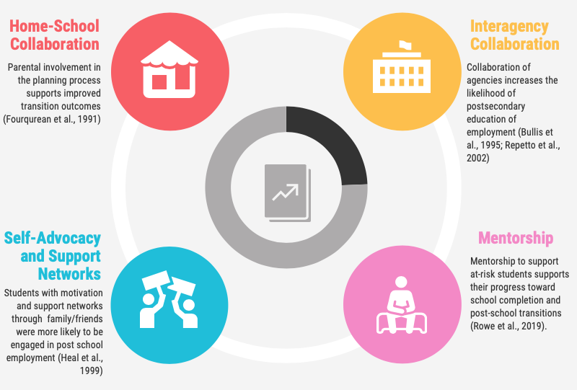
Figure 2. Stakeholder Network

Another important aspect of the transition planning process is ensuring that the learner is prepared for independent functioning in non-academic areas. Figure 3 summarizes these key areas of a school-based curricula to promote the development of youth with special educational needs and disability.

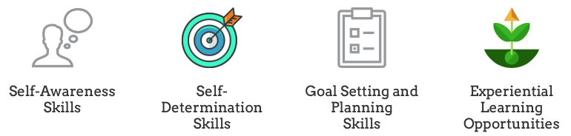
Figure 3. Core skill-sets of school-based curricula

How are self-awareness and self-determination cultivated? In what ways can goal-setting and planning or experiential learning be extended and transferred into everyday life? In its multi-faceted focus, the transition planning and preparation process provides a natural teaching and learning context for life-skills development.
The Training Manual and Toolkit for Secondary Schools: Preparing youth with disabilities for Meaningful Work and Social Participation in Jamaica, was developed by the IDP to support the UNICEF-led initiative to streamline school-to-work transition preparation for youth in special educational programs.
This supplemental resource provides additional guidance in the practical steps to be taken in the transition planning and preparation activities outlined in the training manual and toolkit. Other helpful resources to support greater understanding of transition-planning are provided on the Ministry of Education’s Special Education Unit’s web-page.
Michele A. Meredith (PhD)
STWT Training Consultant
July 2023

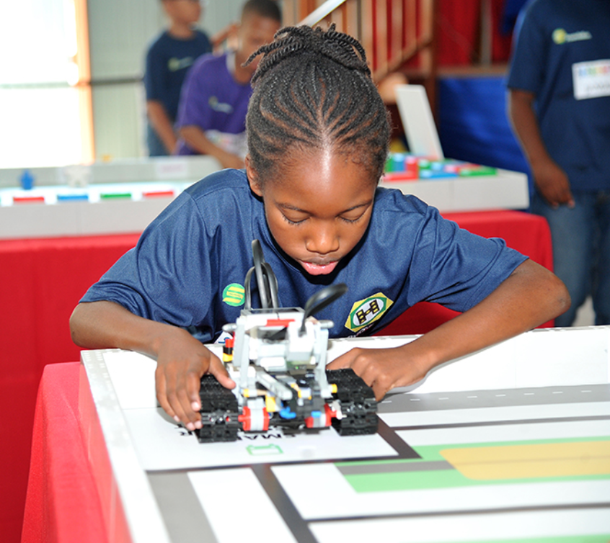
School-to-Work Transition Planning

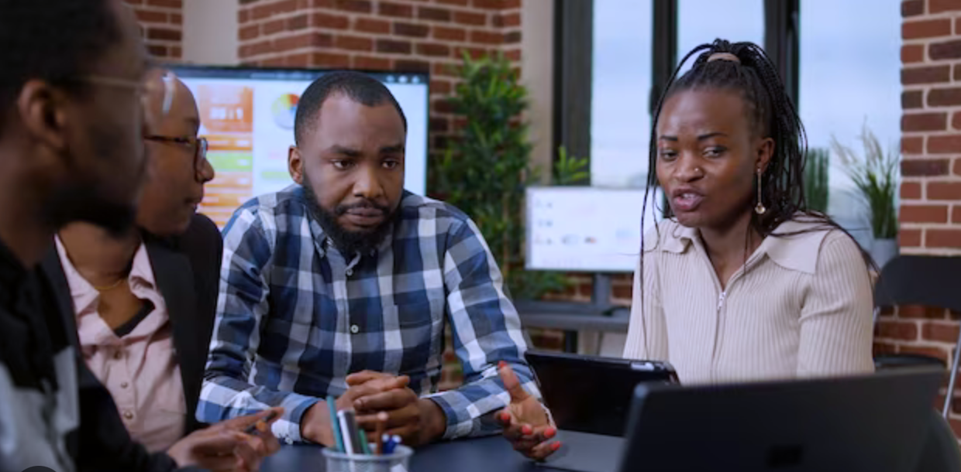
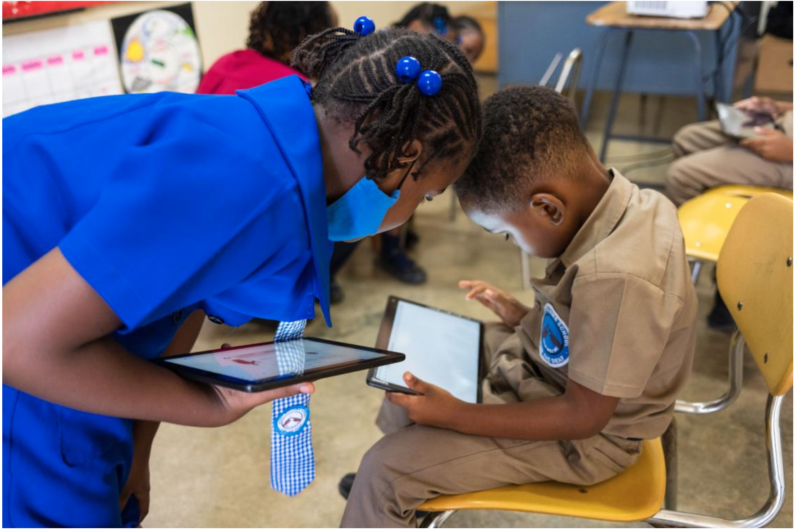


School-to-Work Transition Summary – Planning

What is transition planning?
‘Transition is about planning for life after secondary school. It includes planning for academic and non-academic courses and learning experiences, employment and related training opportunities, community living, and leisure activities. A goal of transition is to help youth understand their disability and choices to determine their future. … transition does this is by connecting youth to teachers and other caring adults, support services, and experiences that build skills and help them reach their goals. Transition is based on family values, priorities, and culture, and is focused on an individual’s interests, preferences, strengths, and needs.’
For the learner with special educational needs and disabilities, plans and activities to support his or her educational experience should begin at the earliest point possible. As the learner moves from grade-to-grade, and across educational levels, careful attention must be given to how services and support will be provided for the learner. Formalized planning for the transition through secondary school, and its exit, should be in effect as early as age 12 years old, but no later than age 16 years old.
Transition planning covers all phases of development. The focus at the early childhood and primary levels may not be as pronounced in career orientation as may be seen at the secondary level. Transition into, and through school includes social and adaptive skills, as well as communication, cognitive, and physical skills – across all levels and phases of development. The focus of STWT in this Supplemental Guide is on the specific preparation phase at the secondary level. Figure 4 (overleaf) summarizes the transition planning process, typically unfolding at the secondary level.

Section Focus
In reviewing STWT planning, we include: setting up the STWT team, considerations for the learner, and planning the learner.

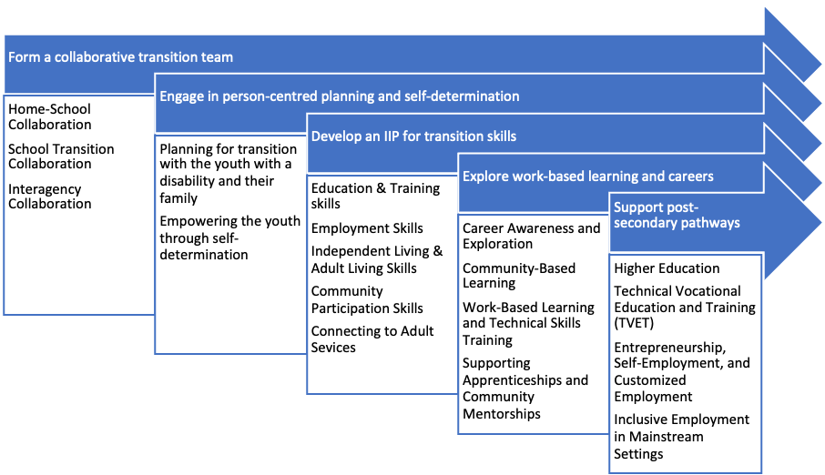
Figure 4. The Transition Planning Process

The STWT Team
The STWT team will guide the planning process for the learner’s transition activities. The transition team should be formed to meet the needs of individual students. The composition of the team will look different for each student as the team will interpret the learner’s needs, and determine the individualized goals for transition-related activities.
The team should include persons with training, expertise, and experience to inform the plans and programs needed to prepare the learner to transition into post-secondary school activities.
NB: Note the proposed STWT team in Figure 5. The team may change in its combination of skills and expertise, depending on the needs, interests, preferences, realities, and goals of the learner.
School Stakeholders | Community Stakeholders | Post-Secondary Institutions
- Student  - Principal  - Classroom teacher  - TVET instructor  - Transition officer  - Guidance counsellor  - APSE Coach | - Parents, caregivers  - Employers or businesses offering work experience, apprenticeship, or volunteer experience  - Disability-focused NGOs or DPOs  - Community supports e.g., churches, town leaders | - HEART / NTA  - Universities  - Abilities Foundation  - Employment agencies  - Direct employers  - Teacher colleges
(Source: Manual and Toolkit, p. 6)
Figure 5. Potential collaborative Transition Team Stakeholders
The team-members listed above have specific responsibilities in the transition planning and preparation activities.

Transition Team Stakeholder Roles and Responsibilities
Stakeholder | Roles and Responsibilities
Student | Communicate preferences, interests, strengths, areas of need, types of support, progress in school toward graduation
Student | Participate actively in discussions, communicate goals to pursue following secondary school, decisions, planning activities, individualized planning meetings, and plan implementation
Student | Communicate accommodations and support needed to achieve goals (e.g., assistive technology)
Parent or Caregiver | Support the student at home in identifying future goals for employment, postsecondary education, and independent living
Parent or Caregiver | Provide information about the student’s strengths, interests, needs, independent living skills, and kinds of support needed to achieve desired post high school outcomes and goals
Parent or Caregiver | Be actively engaged as equal partners in planning, discussions, and decision making
Parent or Caregiver | Participate in making connections to training programs and employment options
Parent or Caregiver | Provide opportunities for the student to practice adult roles and responsibilities
Special Educator (may also be Guidance Counsellor in some schools) | Provide information about the student’s strengths, achievements, progress on personal goals, using IIP goals, if available, and strategies for teaching student
 | Work with student on self-determinations skills to support independent goal-setting and how to develop a plan to reach future goals
 | Assist student in identifying postsecondary goals
 | Prepare student and family for their leadership role in the transition process
 | Suggest courses of study and educational experiences
 | Identify needed personnel from school and community services
 | Link student and parents to post-secondary school services/supports
 | Monitor student progress
Post-secondary Organizational Stakeholders (e.g., HEART Trust NTA, local universities, employment agencies) | Ensure that students and caregivers are able to access information about available post-secondary programs and services
 | Support student and caregiver tours of universities and TVET institutions
 | Employment agencies and employers collaborate with schools to promote work experiences and career exploration opportunities
 | Consider accessibility requirements (e.g., accommodations) to ensure that all youth are equally able to access services irrespective of disability

Points to remember for setting up the STWT Team:
- Identify the persons who would be able to provide the best
Transition Planning Team:
*Caregiver *Student *Special and general educators *Guidance/Career counselor *Transition coordinator/specialist *Job Coach/Work experience coordinator *School system Representative *Clinical Personnel *Transition Service Agency

support to the student
- Approach the individuals to secure their commitment to
serve on the team
- Provide clear expectations for responsibilities of each team
member
- Provide clear information about the duration of time each
- member of the team will be involved
- Provide information about level of time-involvement
(meetings, etc.,)
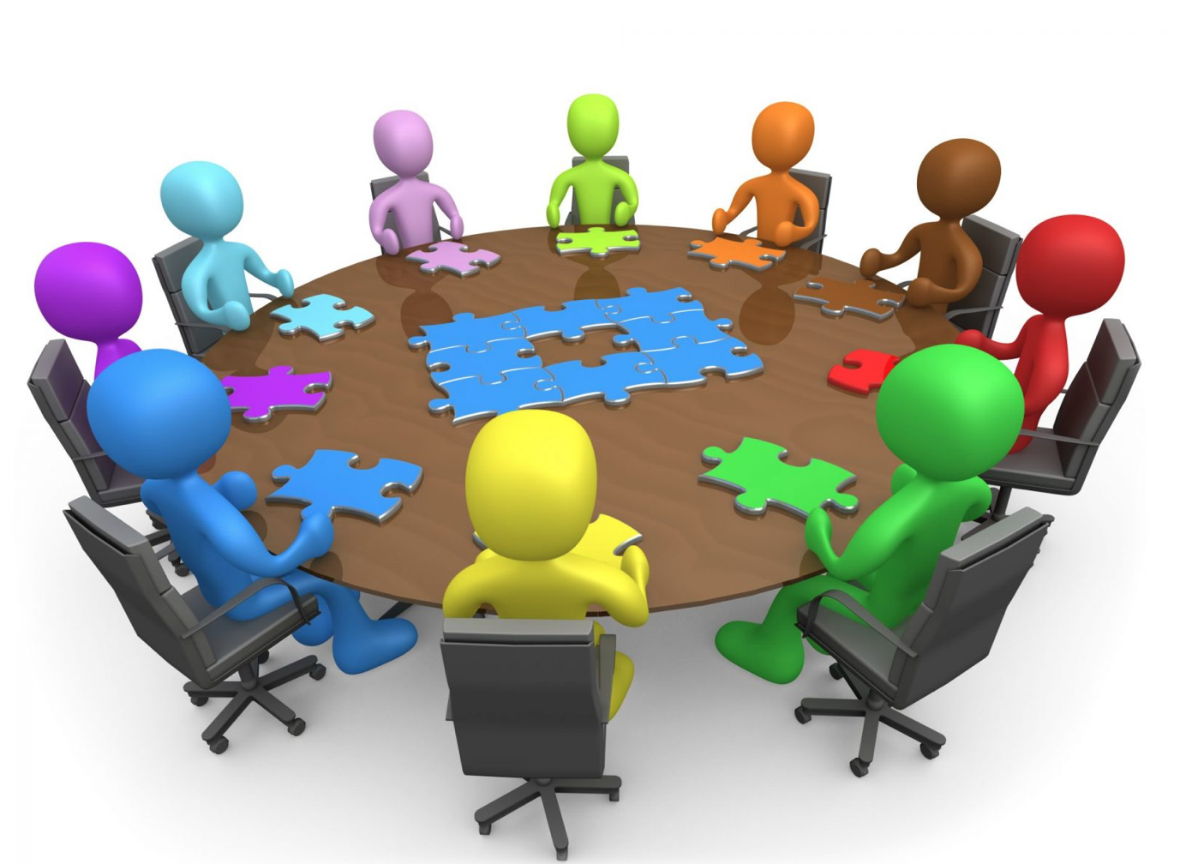

NB: A school may have a general STWT Team. Transition decisions and goals, however, must be addressed as individual cases.

It is important that those responsible for transition planning become as informed as possible regarding services provided by other sectors or agencies.
- The transition needs for the Deaf/Hearing Impaired, Blind/Visually Impaired, or learners with Intellectual Disability, Autism, Learning Disabilities, Physical/Motor Impairments; or Gifted and Talented; or those identified as Twice Exceptional (2E), will vary.
- Needs vary based on special educational need, disability classification, and the extent to which the learner is affected or functions.

Considerations for the Learner
A transition plan should allow students to gain the best experiences in an area closest to their interest, and to the extent their abilities allow. It is helpful to understand the range of job options in a particular field, and ensure the student is guided practically and positively toward their best fit for work-experience and employment. For example, a student who likes to work with plants may explore work-experience options in gardening, landscape manicuring, landscaping, or greenhouse gardening. From this area of interest, the learner may specialize in the treatment of trees, house-plants, or roses. The plans for transition should not be made without input from the student; nor can they be made without understanding how the categories of disabilities or special educational needs influence their educational needs.
Considerations for Instruction
- Begin the discussion about educational paths and career interests early (recommended age 12 years old)
- Identify interests, and align occupational training activities with interests, strengths, and preferences
- Help the learner to identify strengths, areas for improvement, and how to communicate needs
- Help the learner understand their special educational need or disability, and the possible emotional or behavioral effects; or actual effects of their behavior
- Help them identify strategies that support their learning
  - Incorporate the use of adaptive and assistive aids to enhance learning
  - Incorporate concrete hands-on instructional activities
- Include students in the discussion for transition planning
- Set realistic transition goals, and support the family in understanding the need for a suitable transition path

Considerations for Categories of Special Educational Need and Disability

Supporting learners with Learning Disabilities (LD)
Learners will often demonstrate average to above average intelligence. Learning Disabilities are related to central processing dysfunction and may affect the individual across their life-span. The learner may be affected in his/her perceptual skills, ability to process, retain, or retrieve information, and interpret directions. Patterns of performance may also be inconsistent or unpredictable. S/he may also perform well in one area of academics, but poorly, in another. For example; the learner may do very well with language-related skills, but may have significant difficulty in the area of Mathematics.
How do you support?
- Prioritize daily tasks
- Adapt instruction to identified learning style
- Cultivate a supportive learning environment
- Create a supportive learning environment
- Create opportunities to use and develop self-help procedures to improve organizational skills (using a notebook, calendar, time-management, e.g.,)
- Teach self-management, and test-taking, and study skills
- Allow alternative means to assess learning
- Encourage positive peer-group support
For transition:
- Focus on career preparation activities
- Provide instruction to develop the learner’s understanding of job-related vocabulary
- Provide instruction to develop social and independent skills

Supporting learners with Intellectual Disability
The terms mild, moderate, severe and profound levels of functioning describe the range of Intellectual Disability. The extent to which the individual is affected by the disability determines how much support is needed throughout their life-time. The diagnosis of ID is reflected in the combination of diminished functioning in cognitive, physical, social, communication, and life-skills. Learners with ID need practical and structured instruction in functional academics and non-academic tasks.

How do you support?

- Keep instructional tasks structured, and consistent with the learner’s abilities
- Modify instruction to meet the desired instructional needs
- Incorporate and emphasize functional and practical tasks which will be used frequently
- Teach skills in settings in which skills may be transferred naturally
- Provide opportunity to practice social, problem-solving, and life-skills
- Model appropriate social skills consistently
- Encourage positive peer-group support

For transition:

- Encourage the practice of functional skills out-of-school
- Continue community-access and exploration to support independent functioning
- Continue to teach time-management, organizational, problem-solving, and life-skills
- Continue to improve social skills by using social cues in natural interactions
- Allow flexible arrangements for a variety of job-sampling experiences
- Organize peer-group support

Supporting student who are Gifted and Talented (GAT)
Gifted individuals demonstrate exceptionally high levels of functioning in intellectual, creative or specific skill areas. Giftedness may sometimes be overshadowed or undetected by emotional or behavioral challenges. Learners classified as GAT perform significantly higher than their chronological age, but may also show gaps between functioning and social skills. For example, a 3rd grader may function at the 8th Grade level in mathematical reasoning, but her social skills may be at the developmental level of her age peers.

The GAT learner may show varying interests which may change as s/he matures. It is important to provide guidance in the areas of interest for academic or occupational paths.

How do you support?

- Provide accelerated and enriching instructional arrangements (flexible time-tabling, advanced placement, e.g.)
- Encourage enriching activities in identified areas of interest
- Use instructional approaches that cater to learning styles
- Nurture the development of positive self-esteem positive self-image
- Teach organization, time-management, and decision-making skills
- Provide and arrange pre-vocational job-sampling experiences aligned to the learner’s interest
- Support the learner’s exploration of atypical or nontraditional career options
- Encourage peer-group support

For transition:

- Provide opportunities for socializing with peers with similar interests
- Provide exposure to a variety of employment opportunities and arrangements
- Provide career counselling to help the learner identify, explore, and broaden career options
- Encourage interactions with role-model or mentor in the learner’s area of interest

Supporting the learner with Emotional Behavioral Disorders (EBD)

Individuals diagnosed with Emotional/Behavioral Disorders (EBD) show aggressive antisocial, disruptive, and, at times, self-injurious behaviors. These behaviors may be seen in the school or other settings. The learner with EBD may not be able to manage the triggers, or regulate behaviors when they arise. The learner may become withdrawn, or display negative patterns of behavior. In some cases, the learner may resist authority, engage in gang activity, become delinquent or truant, or may engage in substance use. Many behavioral disorders such as mood disorders, depression or schizophrenia are linked to genetic factors. Abuse, neglect, punitive discipline, over-exposure to highly negative environmental and social stimuli may be linked to negative social, emotional behavior issues. The learner with EBD requires much support as they develop and prepare for independent living.

How do you support?

- Ensure early assessment of suspected behavioral or emotional disorders so the learner may be supported appropriately
- Provide highly structured learning sessions and activities
- Modify instructional tasks to align with the learner’s need
- Model and teach appropriate verbal and non-verbal communication skills
- Provide consistent feedback and corrections of inappropriate or unacceptable behaviors
- Teach organization, self-management, and problem-solving skills.
- Encourage positive peer support

For transition:

- Teach work-related social skills and behavior
- Teach social and environment cues
- Provide positive and immediate feedback for appropriate behaviors and skills
- Teach consequences of inappropriate behavior as they may apply in or out of school
- Reinforce personal and social skills

All youth should receive support to develop foundational, functional daily living, and digital knowledge and skills; cognitive, social, and emotional skills; and career and work readiness skills.

Supporting the learner with Physical and Multiple Disabilities
The learner with a physical disability, or multiple disabilities may not always have learning challenges. Although individuals may be born with disabilities, some disabilities are acquired because of accident or illness. Multiple disabilities refer to co-existing disabilities, such as: intellectual disability and autism; or physical disability and hearing impairment, for example. An individual with Cerebral Palsy may not necessarily have a learning disability, in the same way that the presence of a physical disability does not mean the individual has a learning disability.

There are some individuals, however, whose diagnosis present more demand for appropriate solutions. For example, they may need accommodations in the learning environment to help them navigate the physical space. The learner with physical or multiple disabilities may need extensive educational support, and even more attention to transition preparation for independence, self-support, and adaptive skills.

How do you support?

- Provide clear, structured instructions
- Simplify tasks, orally or in writing
- Provide multiple options for learners to access information and demonstrate learning
- Provide a learning environment that allows adequate room for mobility
- Teach skills that may be reinforced at school and mastered at home
- Teach skills toward mastery and independent, automatic functioning
- Encourage peer-group support

For transition:

- Assist student and family to identify and access services for post-school needs
- Provide instruction in functional skills and community-based skills
- Teach age-appropriate self-care, social, and communication skills
- Teach self-advocacy skills for self-management, personal and accessibility skills
- Teach self-monitoring and organizational skills for daily living
- Model and teach appropriate job-related social skills, and interpersonal skills

Supporting students who are Deaf/Hard of Hearing
Students who are Deaf or Hard of Hearing are capable of successful educational outcomes. Educational considerations should include accommodation, and specialized instructional and assistive technological support. Individuals may be born with a hearing loss, or acquire them through bacterial or viral infections, or environmental impact (loud noises affecting the ear drums). A hearing loss may be mild, severe, or profound; may be sudden or gradual. In some cases, individuals may have acquired speech and language before a hearing loss, and may be able to function with better advantage in the hearing context, than their peers who had not acquired language.

The student who is Deaf/Hard of Hearing may not have a cognitive challenge, but may experience limitations in their understanding of nuances in language, social cues, and abstract information. They may use other strategies such there may be. Some individuals may use sign language, lip reading, or speech or other strategies to learn.

How do you support?

- Seat student where s/he is able to see teacher’s face clearly (to allow lip-reading)
- Provide instruction relative to the student’s need and abilities
- Nurture self-esteem, self-confidence, and self-awareness
- Teach and model appropriate social skills
- Teach appropriate and alternative means of communication (auditory training, e.g.)
- Ensure student to be assertive in asking questions to ensure understanding of content
- Modify instructions and modes of assessment to ensure fair gains in learning
- Encourage peer-group support

For transition:

- Continue to use multiple methods of communication for social interaction
- Teach job-related social skills
- Model and reinforce appropriate social skills
- Provide opportunities to practice social and communication skills
- Recruit and provide peer mentors for job coaching and work preparation
- Provide experiences for job-exploration and options for employment arrangements or settings

Supporting students who are Blind/Visually Impaired

The range of visual impairment in the classroom may include low vision, partially sighted, legally blind, or blind. Some conditions may also be progressive or degenerative, requiring accommodation and other educational arrangements. Not all Blind or Visually Impaired will have learning challenges. For many, they may be able to function well in other areas of development, and the loss of vision is the most, or only challenge they face. Students may function well in school with the necessary support and accommodations to enhance learning.
Transition plans should focus on preparing the individual to function with heightened awareness. Such skills are necessary to access a world to be experienced without sight, or limited sight.
How do you support?

- Focus on developing listening and other compensatory skills
- Teach, and allow the use of Braille
Provide information in enlarged print, voice recording device, or Braille
- Provide highly structured lessons
- Give clear, short, sequential directives for learning and other activities
- Align instruction and assignments to student’s ability
- Use age and ability-appropriate strategies and materials
- Teach transferrable self-management and self-monitoring skills
- Encourage peer-group support

For transition (The learner who is Blind/Visually Impaired):

- Use activities that reinforce community orientation and independent-mobility training
- Continue training in adaptive technology, or help student to identify a variety of adaptive devices
- Expose student to multiple work-arrangements, (sheltered, integrated, or group employment options e.g.,)

Supporting students with Autism Spectrum Disorder (ASD)

Autism Spectrum Disorder (ASD) is a developmental disability, a disorder of the Central Nervous System (CNS). It results in difficulties with communication and social interaction, and restricted, or repetitive behaviors or interests. The individual with disability may have difficulty processing information, and may experience heightened sensitivity to sound and touch; and may have different responses to pain, scents, or stimuli in the environment.
Individuals with ASD function differently in learning, mobility, and communication. Individuals with ASD may exhibit low to high levels of cognitive ability. Adjusting to learning structures and interactions may be confusing for the individual with ASD. In some instances, the individual may be withdrawn, engage in ‘fixated’ behaviors, or may have emotional outbursts. Other behaviors may include ‘tuning out’, unawareness of fear, fixated curiosity, mood swings, self-stimulating or self-injurious behaviors. Individuals with ASD may also display discomfort because of interrupted daily routines, changes in structure, or being in unfamiliar places.
ASD is not to be confused with Intellectual Disability or Learning Disability.
How do you support?
- Focus on structure and routine
- Provide clear and timely alerts to changes in structure or routine
- Teach responses and strategies to cope with changes in routines or structure
- Be prepared to be flexible and responsive to student’s moods or response to changes
- Maximize opportunities for students to absorb an retain concepts (pre-teach, repeat, guide, repeat, e.g.,)
- Use concrete, tangible, hands-on methods of instruction
- Reinforce instruction and present materials visually and verbally
- Establish clear expectations for behavior, and apply fair and consistent system of reward
- Teach and exercise behavior management and reinforcement according to natural consequences
- Teach and model appropriate social, self-management, self-monitoring, and organizational skills for transfer outside of the classroom context
For transition (The learner with ASD):
- Focus on developing functional skills across school and home
- Continue to focus on communication and social skills (including job-related social skills)
- Continue to keep daily routine skills consistent
- Continue to teach coping strategies to address disrupted routine
- Create opportunities to reinforce community-based interaction and experiences
- Teach self-prompting skills for work-routines
- Establish peer-group support

Planning for the Learner
Transition planning is person-centered and interest-focused. The Individual Intervention Plan (IIP) or Individual Transition Plan (ITP) will include goals and skills to be developed to guide the learner into transition.
The following steps are critical to remember:

Setting the foundation for transition planning
- Is there a diagnosis of a disability?
- To what extent does the disability affect the learner?
- In what area is the learner affected (learning, social skills, communication, physical skills, or adaptive skills)?
- What is the current academic functioning of the learner?
- Is a skill or career interest identified?
- Is the skill or career realistic considering the learner’s functioning level and capability?
- Are there options for other skill or career areas selected?

Engaging the learner for transition planning
- Identify with the learner’s input:
  - what are the academic skills needed to prepare the transition path?
  - what are the personal skills needed (self-determination, self-advocacy, mobility training, communication, etc.,)?
  - what are the areas for independent living, community participation, support or services to be added to transition goals?
  - what are the activities, programs, persons or agencies that need to be considered or included in the plans toward reaching his/her goals?
  - what are the pre-vocational or work-experience goals to be included in the transition plan?

Engaging the family for transition planning
- Identify with the learner and family’s input:
- What are the concerns for the learner?
- What is the family’s goal or hope for the learner?
- Is there a support network in-place to help the learner into transition?
- What are the resources needed to support the learner into transition?

Evaluating the school support for transition planning
- Does the school’s program or curriculum contain the content needed for the learner’s transition goals?
- Are the necessary personnel available to support the learner’s transition goals?
- Are the roles and responsibilities of personnel defined clearly?
- Does the program structure include monitoring of each transition planning phase? (From the initial to final transition planning goals, e.g.)
- Does the program structure include the support and involvement of internal or external partners to ensure practical transition experiences?
- Does the program structure contain systems of accountability to ensure successful transition support for the learner?
- Does the program allow for documentation to inform future transition planning?
The questions above are very important in ensuring the foundation is laid to support the learner’s goals for transition. The goals for the transition plan should be stated clearly to ensure all involved parties understand. Goals for transition should be SMART:
- Specific: What exactly do I want to happen? Who will be doing it? What resources will I need?
- Measurable: I will know I have reached my goal when…
- Achievable: Is this goal realistic and possible to be done by the deadline? How?
- Relevant: What impact will reaching this goal achieve?
- Time-bound: I will reach my goal by the following date
(Training Toolkit, p 20)

See pages 13-21 of the Training Toolkit for further guidance.

School-to-work Transition Preparation

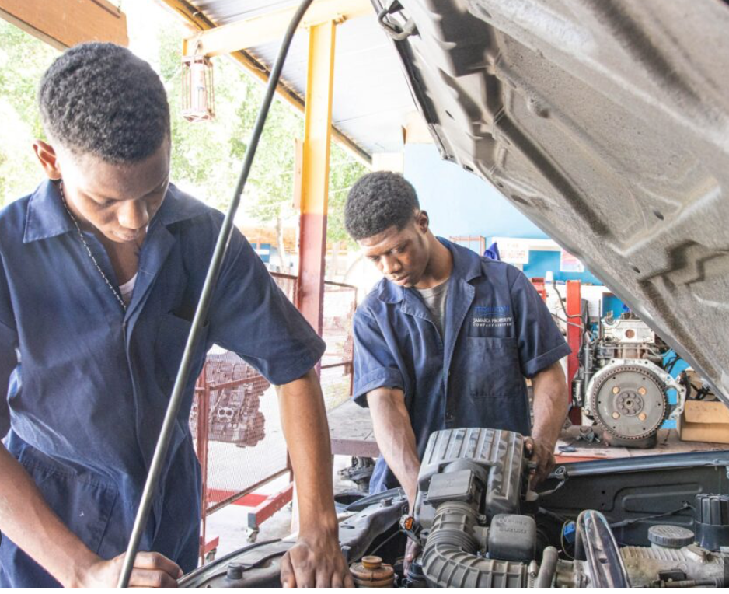
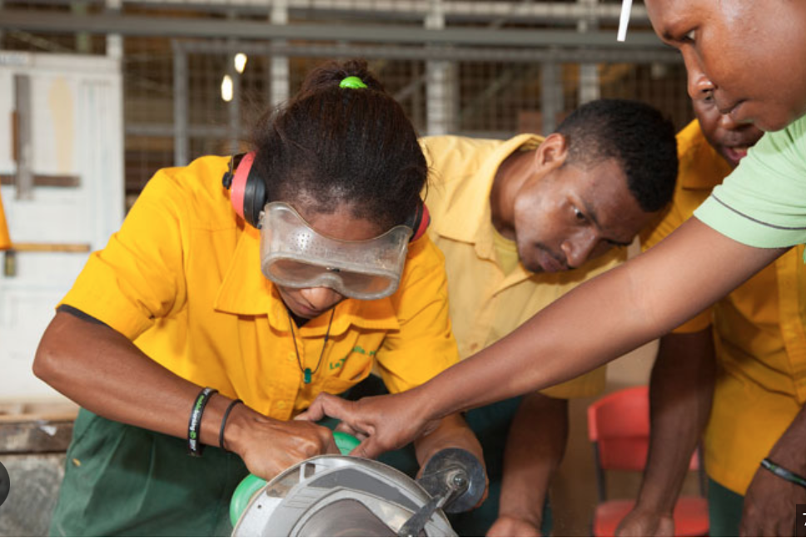

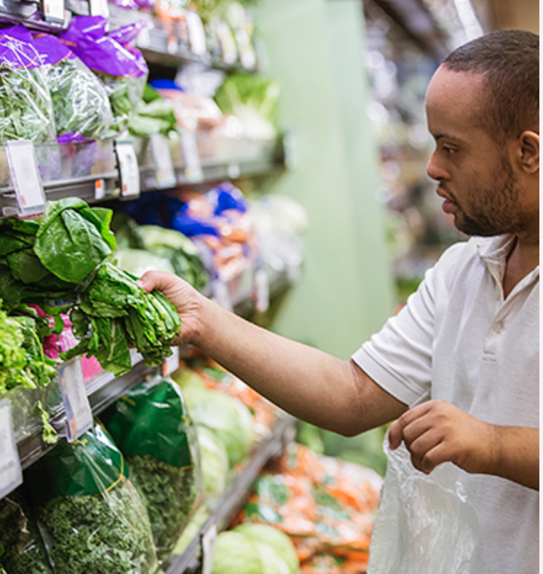


The Transition Plan
The Plan for transition should reflect clear guidance that leads the learner along a path to independence. The goals and objectives should lay the foundation for practice in key skills and competencies in multiple areas of development, for improved independent living outcomes. The diagram below gives a summary of one way in which the planning process might evolve.
Before beginning to plan for transition, it is important to know the learner’s interests, preferences and abilities.
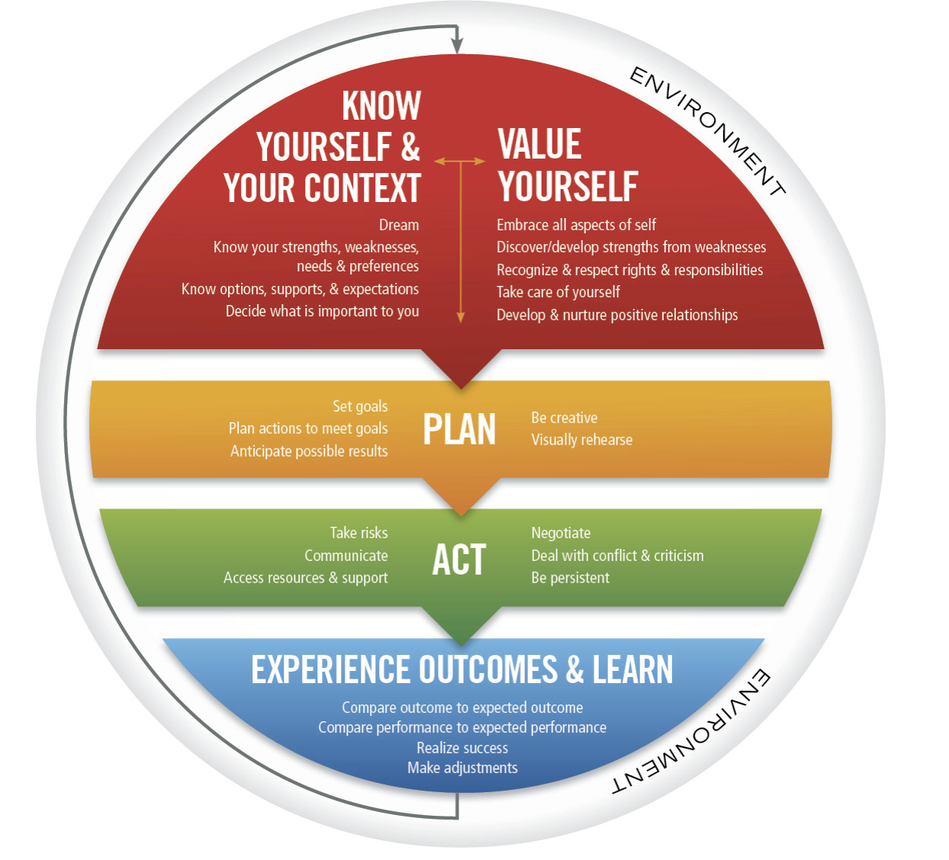
Figure 6. The action model for self-determination
Parents, caregivers, teachers, and others who interact with the student should be aware that the student may not understand how to state his or her ambitions, plans or goals. It is important, therefore, to lead the student into a path of self-discovery. The conversations about transition preparation and planning are crucial nurturing moments for the learner.
The diagram shows us that the individual’s evolving experience is influenced by the environment. Regardless of how life evolves, the individual is part of an environment, contributes to that environment, and is influenced or affected by the environment. Based on the diagram, note the following suggestions for the individual:
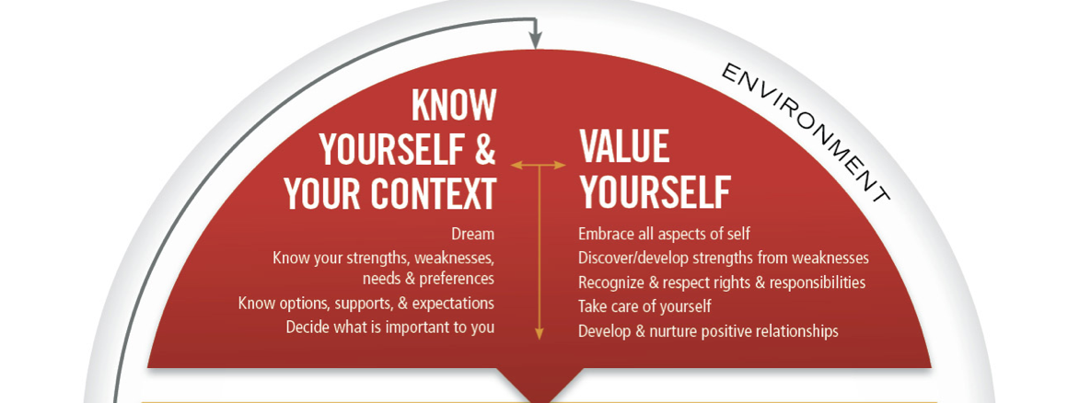

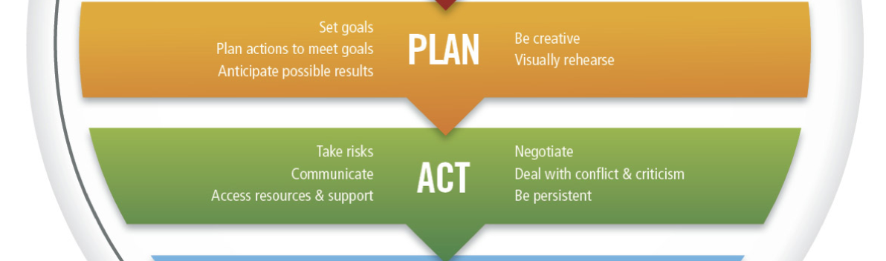
Know yourself and your context Value yourself
Be aware of dreams or hopes; know the options for support, and the expectations of the path to be taken to achieve goals and dreams. Be aware of areas of strength, weakness, and needs. Let those points drive the decision, based. On what is important to the individual. | Accept the combination of strengths and areas for improvement. Work to address those areas; recognize and accept rights and responsibilities; and cultivate a positive, healthy image of self.

Plan | Act
Understand what is needed for development and success. Use this knowledge to for relevant planning to address needs and goals. | Take the necessary steps to pursue the  goals outlined in the plan. Be guided by  timelines and possible challenges.

Experience Outcomes and Learn
Engage in activities and actions toward the set goals. Monitor progress toward goals, by matching actual progress with goals. Make the adjustments to ensure success and realistic outcomes.


Team Meetings
With the areas emphasized in the diagram, the step-by-step planning and preparation process should include the family, related persons from the school, and other persons who might be involved in supporting the transition goals.
Who should form the team?
- Parent or caregiver | - Guidance Counsellor or Career Counsellor
- Student (if able to) | - Transition Specialist/Coordinator
- Representative of the family | - Job Coach or Work-experience coordinator
- Other resource person or service provider | - Education Officer (assigned to the school)

If the transition plans are to be relevant and practical, everyone has to be given the chance to contribute to the discussions. Persons forming the team should be committed to guide and support the student to succeed in preparing to take on adult roles and responsibilities. All members of the team should work together to guide the preparation to cover all areas of the student’s life.

Critical steps for the Transition Team
- Decide on the frequency of meetings with the input of others | - Discuss how school-experiences may help the student to prepare for transition
- Discuss the plans with members of the team | - Help families identify the agencies which may provide support after school
- Listen to all points, ideas, and suggestions | - Assign persons with specific responsibilities
- Representative of the family | - Job Coach or Work-experience coordinator
- Other resource person or service provider | - Education Officer (assigned to the school)
- Agree on time-frame for paper-work where necessary | - Ensure that members of the team agree on the decisions and actions to support the student
The student’s Transition Plan will be the document that will guide the action on the goals and focus for the meeting-discussions.

Critical points to drive the discussion of the Transition Team
- Identify areas of need for academic, career, post-secondary education | - Identify how the career goals align to the student’s current course of study
- Identify the student’s strengths and areas for improvement | - Identify the student’s needs for support or improvement, and how they will be addressed
- Identify what types of support will be needed to enter post-secondary education | - Identify the institutions which could be considered most suitable for educational or vocational programs, after high-school

The Guidance Counsellor’s Role
- Provide career counselling with a group or individual focus | - Ensure counselling aligns with the student’s transition plan
- Provide guidance; or collaborate with work experience coordinator to ensure placement is suitable for the student’s interests or preferences | - Organize or lead activities to support the transition into independent functioning, post-secondary education, or employment

Home and School Collaboration
During the years of the transition preparation process, the family and school should develop a relationship cemented by cooperation and collaboration. Consider the following as the student becomes older:
- developmental needs change
- the level of competence in social skills increases
- connections between what is taught at school and reinforced at home become more relevant
- goals for school-leaving outcomes become to bear great significance
In order to support collaboration between home and school, the Training Toolkit (2.1) suggests the following principles for collaboration:
Face-to-face interactions | holding meetings regularly, (face-to-face, where possible)
Positive interdependence | Transition Teams functions as a supportive and organized group, working toward agreed goals
Effective use of social and interpersonal skills | respectful interactions, safe place on which to share opinions; and a willingness and readiness to resolve conflict
Individual accountability | commitment to fulfil agreed roles and responsibilities
Group processing and monitoring | reviewing and monitoring the effectiveness and outcomes of the collaboration
As the student in a special education program begins to move toward adulthood, the nature of the relationship between home and school should truly look more like a partnership. Both entities should want the same practical, relevant, and achievable outcomes for the student. Mutual trust becomes an important facet of this relationship as home relies on the guidance of the school, and the school relies on the home to be consistent and committed in working toward the student’s goals and ambitions for transition.

School and Community Collaboration
Collaboration for transition preparation extends beyond home and school to include community partners or stakeholders. The interest the student has for work or vocational training may be inspired at school, but may need another context in which it can flourish. Community partners working with the school may be able to add great value to the school’s work-experience and career development program. These partnership groups may involve:
- Social welfare, or service and support agencies (e.g. Jamaica Council for Persons with Disabilities, Jamaica Association for the Deaf, Jamaica Autism Support Association, Jamaica Association on Intellectual Disabilities)
- Educational and training facilities (e.g. vocational and skills-training institutions, community colleges, higher education)
- Community-based organizations (e.g. religious groups, Food for the Poor, Breadbasket Ministries, Operation Friendship, Save the Children)

Interagency Collaboration
As the transition preparation process unfolds, the limitations of the schools and the involvement of community partners points us to another level of collaboration. Ministry Departments and Agencies (MDAs) are essential partners in the transition preparation process. The services, programs, projects, or funding available through MDAs may be available to fortify the efforts of the school in preparing youth with disabilities for roles in the future.
For example, the JCPD, an agency of the Ministry of Labour and Social Security may mount a job fair for youth with disabilities. They may invite the Combined Disabilities Association to participate and promote its mission and programs. Another example may be the Ministry of Education and Abilities of Foundation working together in a recruitment drive to invite youth with special educational needs for their vocational skills program.
This diagram below captures the many elements that may make the transition preparation process meaningful. A major element of the process is mentorship of the student for transition. Mentors may include school personnel, family, but also community partners.

Transition Teams may be very effective in setting the foundation for the success of the student transitioning into adult roles and responsibilities. Collaboration and resourcefulness among the Transition Team and committed stakeholders may work successfully to facilitate positive transition outcomes.
The Toolkit (2.3) lists the following points for successful transition planning.
- Depth of knowledge of transition issues
- Capabilities and expertise
- Strength-focused
- Aware and competent in diversity issues
- Communicates openly
- Shares responsibility
- Networks effectively
- Has access to resources
See pages 7-11 of the Training Toolkit for further information on transition preparation.

Planning for the Student – Critical Considerations
The Transition Team in its meetings should have the student’s future at the heart of the discussions. The future of the student is determined by the goals set in the Individualized Transition Plan. The plan should include goals for academic, social, independent living, social, and life skills.

Steps to planning
- Start with a transition statement:
  - let the student and family state their goals for transition
    - begin with general goals
    - categorize goals
    - organize goals into more detailed objectives
- State the goals and objectives:
  - what are the specific skills or competencies needed; the level of instruction, the resources needed for the transition goals to be achieved
- Develop the course of study:
  - identify the academic skills needed; identify the independent or employment skills needed.
    - Examples of programs of study:
  - Math, with industrial arts prevocational classes with a focus on construction fields, job shadowing, community exploration, and work-experience.
  - Functional math, functional literacy, home-management, health and food service courses; and courses for independent living skills.
  - Functional math, functional literacy, integrated science with exposure to agricultural skills, animal husbandry, and crop care, job-shadowing, and work-experience.
  - Functional math, functional literacy, science, with exposure to human and social biology, community exploration, job-shadowing, and work-experience.
- Guide the students through career exploration and skills for career-preparation
- Help students with career-planning goals; ask key questions and help them understand their goals and prioritize the steps to practical and realistic outcomes
- Work with students to create career-portfolios that include career-related research and targeted action.
Note the diagram below and how it presents the steps to guide the Transition Team into transition planning and preparation.

Note pages 18-20 (Training Toolkit) for more information on developing an Individualized Transition Plan.

Incorporating Transition Plan into the Individualized Intervention Plan (IIP)
In the same way other goals and objectives are documented for and IIP, the plan for transition should be documented as well. For example:
Jason hopes to work in the family legal firm providing support in the Document Office. He intends to continue living at home, but will gradually move into the smaller self-contained section of the house. He will continue his involvement at church where he is a member of the music team.
The transition statement may be revised as Jason continues with his transition preparation. As exposure, experience, and competencies causes him to mature, the goals may become more defined or may be revised.
The transition statement leads to the development of the student’s course of study. The course of study is the student’s educational plan, inclusive of technical or pre-vocational activities.
A course of study is a cluster of content across specific subject areas and disciplines, for example:
Functional math, functional literacy, home-management, health and food service courses; and courses for independent living skills.
The course of study may be developed based on conversations with the student and family, and under the guidance of the transition team.
The specific areas of instruction should be coordinated to reflect the focus of the transition statement; and how those goals may be met through instruction and supporting activities.
Example of coordinated activities:
  - Instruction
    - Academic instruction, tutoring sessions, pre-vocational simulation activities.
  - Related services
    - Support to aid transition preparation and educational development (speech therapy, mobility training, etc.,)
  - Community experiences
    - Learning opportunities outside the school context, educational field trips and simulation activities
  - Employment and post-school objectives
    - Job-search, mock-interviews, exploring utility or banking services, accessing medical services, etc.,
  - Daily living skills
    - Meal preparation, budgeting, paying bills, grooming, etc.,
  - Functional vocational evaluation
    - Career interest inventories, aptitude and job-readiness skills, etc.,

Steps to develop transition goals
- Assist families to identify goals for post-school outcomes.
- Identify the current levels of functioning, highlighting strengths and abilities.
- Identify the instructional strategies to be used toward the goals and outcomes.
- Identify the related services which the student will need.
- Identify and prioritize the community experiences the student will need during the period of transition preparation.
- Identify and prioritize the daily living skills to be targeted and evaluated as part of the student’s development.
- Identify the service-agencies which may be explored for support and services beyond school.
- Identify work-experience goals, sites, and partners to assist in community work-preparation or job-coaching activities.
- Develop annual goals to be implemented from the beginning of transition planning to the time of exit from school.
- Specify the target-dates for the beginning and end of transition activities.

What should the transition plan include?
- Annual goals: long term, short term, or immediate objectives for the agreed outcomes.
- Specified or projected dates for the beginning and duration of services, and targets for evaluating objectives; and whether they are met.
- Appropriate objectives, performance criteria, evaluation procedures, and schedules for evaluation within the general academic curriculum.
- Statement of how progress will be monitored and measured during the transition-preparation period.
- Modifications and accommodations relating to instruction, assessment, or other service provision.
- Procedures for reporting the student’s progress to parents.

Life-Centred Education Curriculum
The Training Toolkit recommends adopting the Life Centered Education Curriculum (LCEC) as supplemental curriculum. The LCEC is developed by the Council of Exceptional Children (CEC, USA), to be used for students with disabilities who are in transition-preparation.

Example of the Life-Centred Education Curriculum
Daily Living Skills Matrix. The matrix is broken down in a domain, competencies and sub-competencies.
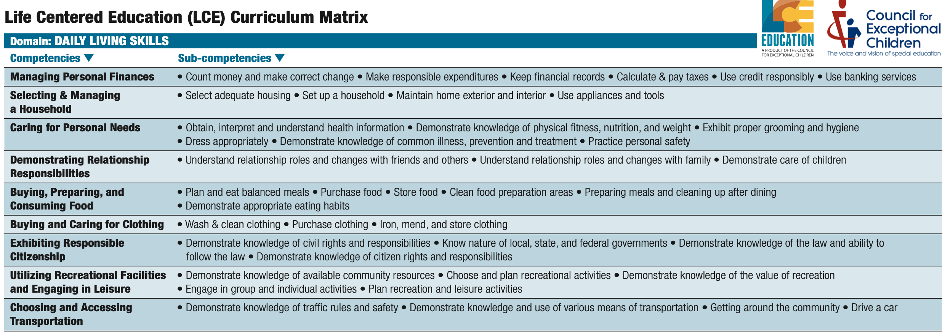
Looking further at the matrix, take the competency: ‘Caring for Personal Needs’, note that the sub-competencies:
- obtain, interpret, and understand health information
- demonstrate knowledge of physical fitness, nutrition, and weight
- examine proper grooming and hygiene
- dress appropriately
- demonstrate knowledge of common illness, prevention, and treatment
- personal safety

Example of the Self-Determination and Interpersonal Skills Matrix (LCEC)
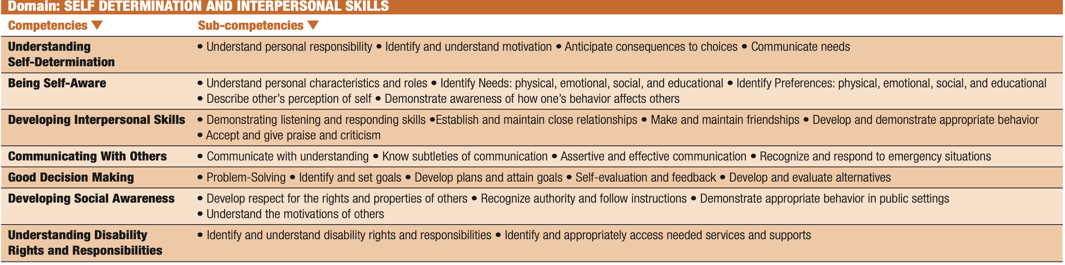
Take the competency, ‘Being self-aware’, and the sub-competencies
- Understand personal characteristics and roles
- Identify needs, physical, emotional, social, and educational
- Identify preferences physical, emotional, and educational
- Describe other’s perception of self
- Demonstrate awareness of how one’s behaviour affects others

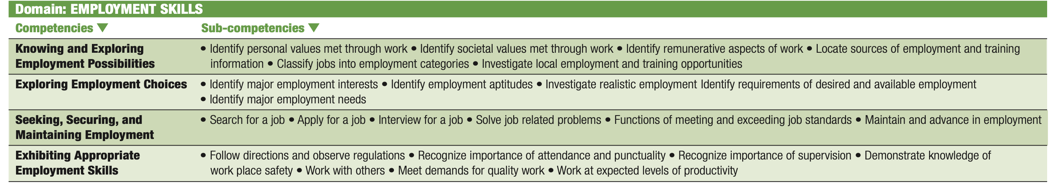
Note well:
The domains are the areas of development, or skills that are necessary for preparation for taking on adult roles and responsibilities. The competencies and sub-competencies should be used in the Transition Plan, presented as goals and specific objectives.

Example LCEC Lesson Plan
The information below provides an example of how the LCEC matrix may be used to create lesson plans. The lesson plan is from the Daily Living Skills domain.

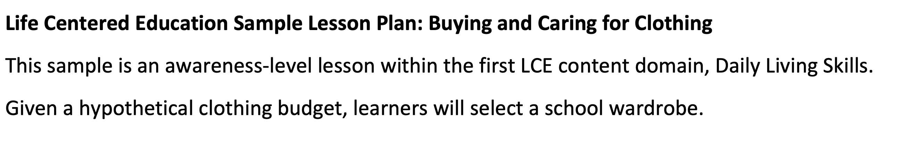

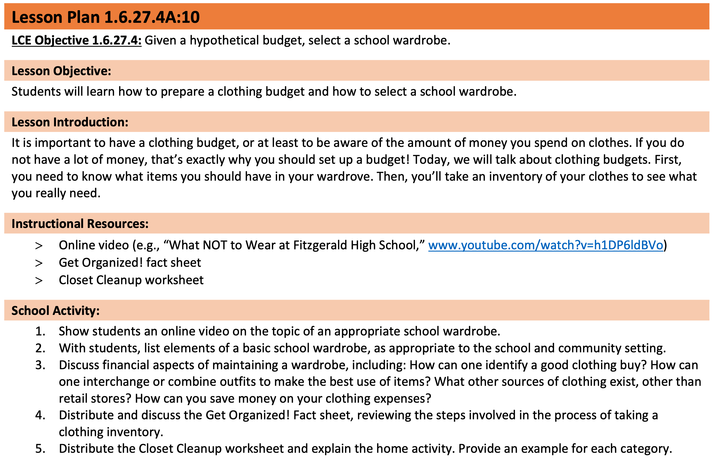
Take careful note of the following:
- The general objective – using a hypothetical budget to purchase clothing for school.
- Lesson Objective (specific objective) – preparing a budget and selecting appropriate clothing for school.
- The lesson introduction sets the foundation for the content that will be covered in the lesson.
- The curriculum provides a video link and other resources to enhance the instruction
- School activities – step-by-step progress through the lesson, including how the resources are to be used.
Recall that the goals for transition are likely to be more successful if there is collaboration between the home and school.

The example below shows how the LCEC provides the following:
- extended connections for skills to be reinforced at the home
- alternative instructional strategies, and
- evaluation of learning

Example of home-related activities:
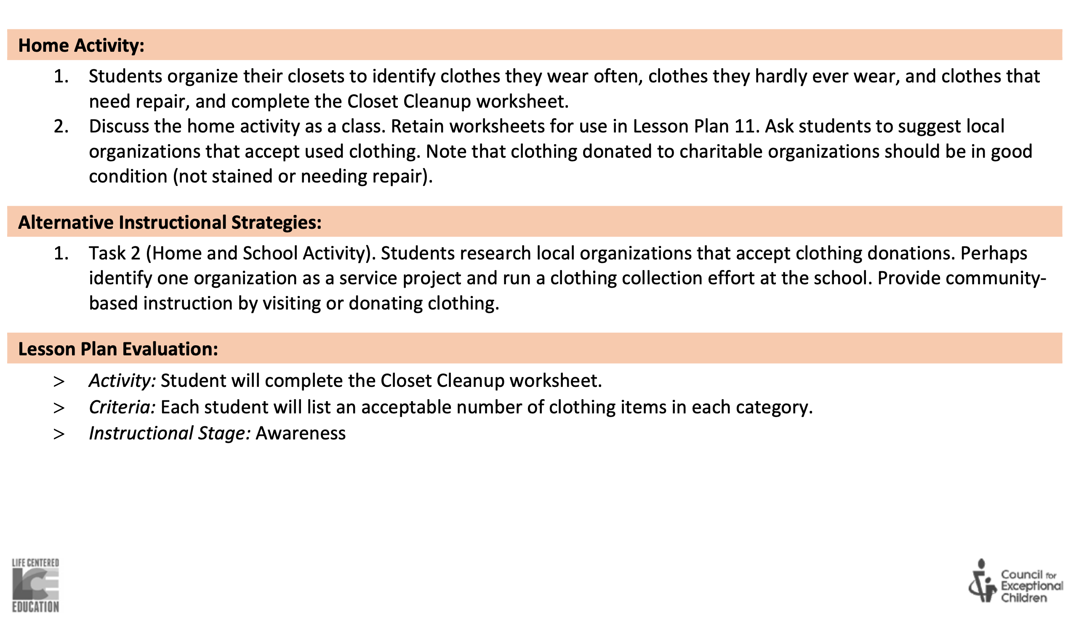

The LCEC also carries with its worksheets to allow practical application of the competencies being taught. The worksheet below is the prepared resource that helps students to apply the skills they learned into practical activities.

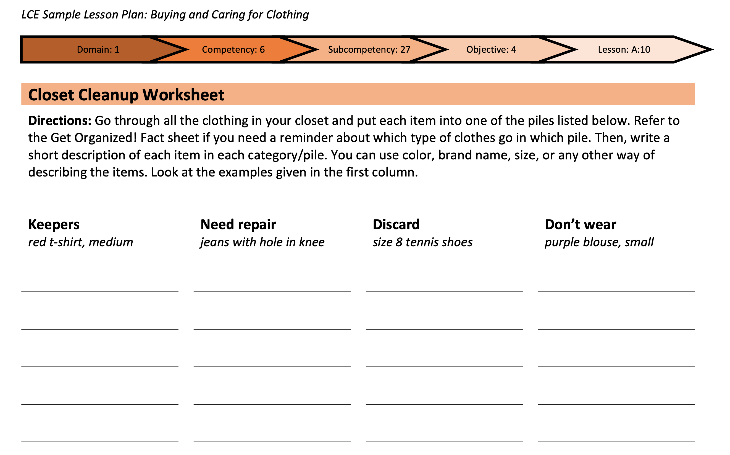

The examples of the LCEC were given to show how a practical curriculum featuring functional academics and developmental domains may be used to develop a lesson plan for transition-related skills.

Application for transition goals in a lesson plan - Planning sequence:

The sequence above is adopted from the LCEC curriculum and may be used as a guide to develop transition-related lesson plans. Let us apply the sequence to the case study below.

Case Study
Carel is 15 years old. She lives with her family including two younger siblings. Her mother is an Art teacher. Carel attends one of the Schools of Hope. Her mother has noticed that she has an interest in sewing. Although her speech is not clear, Carel is very vocal and tries to make her needs known. Her mother has noticed that she writes her requests and places her notes on the refrigerator.
Her mother has described her as being very neat, often taking the initiative to clean her room and her siblings’ rooms. She also spends time in the kitchen with her mother, and attempts to prepare sandwiches and drink for the family.
Carel enjoys school. Her teacher has observed that she is often impatient, and displays tantrum-like behaviors when she does not get to do an activity she initiates in class, although the task was not assigned by the teacher.
Looking at Carel’s case:
Domain | Competencies | Domain | Competencies
Academic | Able to write to communicate needs | Daily living | Very neat, tidies house  Likes to be in the kitchen Prepares sandwiches and drink
Communication | Unclear speech Vocal and expressive | Behavioural | Impatience  Tantrum-like behaviours
School | Enjoys school Initiates activities | Home | Enjoys tasks  Initiates activities  Supportive mother
Vocational | Likes sewing

Let us take the domain of Daily Living for Carel, and apply the sequence.

The information in the part of the sequence is linked to the information from Carel’s case. Based on this information, the goals and objectives can now be written.

The sequence suggested above is linked to Carel’s activities that are reported as a home-related activity. The competencies related to the activity may be improved in formalized instruction. What is taught at school, may be further practiced and reinforced at home. The skills for Carel are broken into sequential objectives. The lesson plan to be developed will include the strategies and methods that are relevant to help Carel succeed in gaining these competencies. The evaluation will be related to the specific objectives and the goals.

Summarizing Comments
This supplemental guide is provided to complement the use of the Training Toolkit. The Toolkit provides information and examples of procedures and resources that may be used in the transition planning and preparation process.
Consult the Toolkit for more information. The on-line repository provides information and other resources that will be helpful in understanding and implementing school-to-work transition activities.

References

Five Tips for creating transition plans for employment. Retrieved
from: http://www.aphconnectcenter.org
Centre for Disease Control and Prevention. Signs and Symptoms of Autism Spectrum
Disorder. Retrieved from: http://www.cdc.org
Schuelka, M. J (2022). Preparing youth with disabilities for meaningful work and social
participation in Jamaica. Training Manual and Toolkit for Secondary Schools; Niad,
H.., Stone, A., & Karr. V (Editors). Ministry of Education, Jamaica.
Prepared by:
Michele A. Meredith (PhD) STWT Project Consultant February 29, 2024

