2024
Summary
This document presents the opinions, concerns, and recommendations of parents and youth regarding transition-preparation experiences, and readiness for life after secondary school.
Thoughts on transition
Parents and Youth
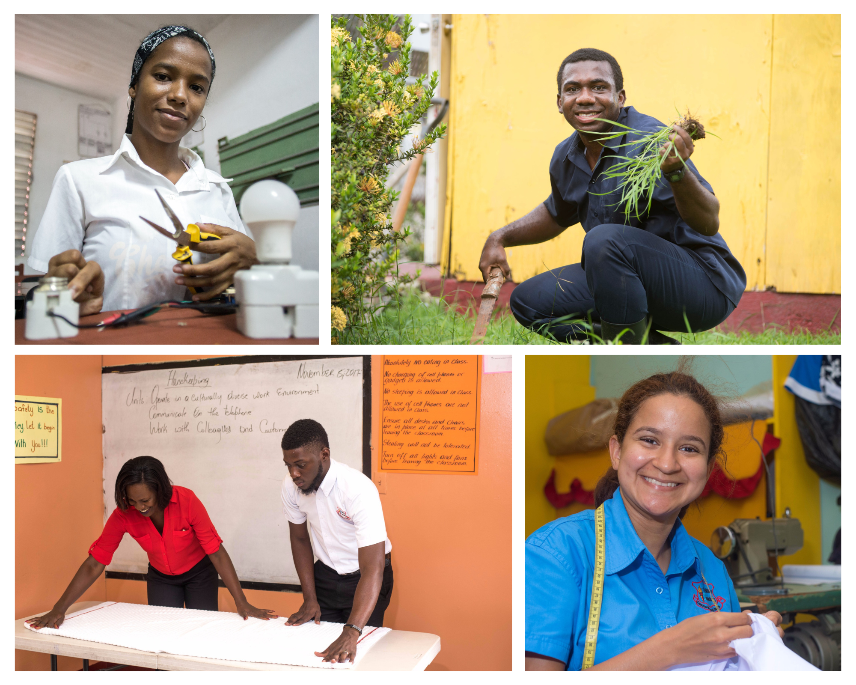
THOUGHTS ON TRANSITION

Context
Focus Group sessions were held with students and parents from Jamaica Association on Intellectual Disabilities (JAID), November 16, 2023; and with parents from Genesis Academy (December 11, 2023), and the Salvation Army School for the Blind (January 19, 2024).
The purpose was to hear the opinions, concerns, and recommendations regarding transition-preparation experiences, and readiness for life after secondary school.

THOUGHTS ON TRANSITION – PARENTS’ FOCUS GROUP SUMMARY
Questions
- High school preparation
  - What was high school like (or has been like) for your son/daughter so far?
- Post-school goals
  - What is your vision for your son’s/daughter’s life after high school?
    - (Think about outcomes for work, further education, relationships, independent living)
- Family Support
  - What are your child’s/ward’s hopes or goals for the future?
  - Do you and your child/ward have similar goals for his/her life?
  - How have you helped to guide those goals?
- School support
  - Are you satisfied that your child’s education provided him/her for life after school?
  - Are you satisfied with the type or level of support you received from the school?
- Recommendation
  - What would you suggest school leadership to be done to ensure support for other youth in preparation for life after school?
The comments below are responses from parents’ focus group. They have been organized based on the general themes or concerns parents talked about.
THOUGHTS ON TRANSITION – PARENTS’ FOCUS GROUP SUMMARY
1) High School Preparation
What works?
In general, schools provided teaching and general preparation for academic skills
What needs improvement?
- Teachers need to be more informed about working with children with multiple challenges or complex needs
- Teachers need to prepare children more for the major changes that happen at the secondary level or higher level of school.
- Parents need training in understanding the changes their children go through as they become older and move in adolescence.
- Better relationship between the schools the children are leaving and the ones to which they are going.
- Better arrangements for placement. Placement in secondary programmes was not always appropriated.

THOUGHTS ON TRANSITION – PARENTS’ FOCUS GROUP SUMMARY
School Preparation
What works?
- Curriculum is appropriate and relevant for the needs of children.
- Teachers are mostly aware of the general subjects to teach to help the children.
- Some teachers are very good at working with the children, and knowledgeable about the areas of need for the growing child.
- It was good to see how children were learning basic skills that would help them at home such as cooking, ironing, cleaning, using the ATM, shopping and other life skills
What needs improvement?
- There is more competence need among teachers to allow them to work with student with a variety of challenges.
- More peer interaction with other students outside of their school or disability group should be provided
- More social interaction with non-disabled peers would be beneficial to the general development and social skills of the students in the special educational facilities.
- Provision of workshops for school staff about skills for life after schools
- Provision of workshops for parents to allow them to provide good guidance and support for their children.

THOUGHTS ON TRANSITION – PARENTS’ FOCUS GROUP SUMMARY
Post-school Goals
What works?
- The teaching from the curriculum and the programmes is good and helpful for getting the children some skills for when they leave school.
- There are some skills experience that are good and even helpful for us as parents to know.
- Many of the teachers really care about the children and can get them to do enough to go the extra step.
- The training for skills lets them [the students] have hope to work after school. My daughter wants to be a journalist and I hope she will get some good skills for that.
What needs improvement?
- They may have skills but they need more for the rea-world workplace. My child got a job but was not able to stay in the job. It just did not work for him. We will keep trying other things.
- Although my child got into a programme after school, he did not seem to be able to manage. A focus on those other things that can help them when they actually get ‘out there’ they can manage on their own.
- There should be more opportunity for our children to socialize with other children outside of their schools so they can do better with social skills when they leave school.
- We as parents need more information and support for our children who cannot go into vocational programmes or work, after they have left school.
- There needs to be more thought for supporting students after they leave school. More support for parents to support their adult children who have more complex challenges.
3) Family Support
What works?
- Families are supportive and willing to help.
- Family members are welcoming and loving
What needs improvement?
- Parents and families need more information about transition from different school, or getting ready for living after leaving school

THOUGHTS ON TRANSITION – PARENTS’ FOCUS GROUP SUMMARY
4) School Support
What works?
- Schools provide support with educational programmes.
- Schools are supportive in helping parents to find services for students.
What needs improvement?
- Schools are not aware of laws or government-related policies that can guide decisions for children.
- Schools are not supported by the Ministry of Education enough. In addition to books, schools need more teachers, devices and modern equipment.

5) Recommendations
- Policy-based support and guidance for parents to provide direction for health-related or medically-involved conditions.
- Support in the form of waivers, subvention, or reduced fees for health-care needs.
- Parents need support as they move into adulthood with their children.
- Consider day-care facilities to support continued developmental and transition needs.

THOUGHTS ON TRANSITION – YOUTH FOCUS GROUP SUMMARY

- Current employment status
  - Are you working? What do you do for work?
- School experience
  - What was high school like for you?
  - What did you study while you were in school?
  - What specific skills did you learn that helped you for life after school?
- Self-evaluated Competencies
  - What would you say you are good at?
  - Did you learn these skills, or are they natural for you?
- Anticipated outcomes
  - Are you doing now, what you hoped or planned to do after school?
- Recommendation
  - If you could go back to school, what would you ask them to teach or do to prepare you for life after school?

THOUGHTS ON TRANSITION – YOUTH FOCUS GROUP SUMMARY
1) Current employment status: Are you working? What do you do for work?
- Period of engagement ranges from 1 to 3 years.
- Other students were currently in job preparation
- Jobs included bakery in a supermarket; cosmetologist/aesthetician; food preparation; clothing construction.
- Varying phases of experience.
2) School experience: What works?
What was high school like for you? - General satisfaction with high school.
- The activities and skills learned were helpful for what we wanted to learn as we went through different grades.
- The options for employment-preparation were liked, and were helpful in job decisions.
- Teachers helped us with the understanding work-skills.
- I was glad to be at school so I learned some things I wanted to learn; but I did not like everything.
- I learned to be more responsible.
- I learn about success and school helped me plan my life.
What needs improvement?
- We need a longer time to learn more so that we can be better on the jobs.
- Our parents should know more about what we do so they can help us more.
What did you study while you were in school?
We had classes in Mathematics, Language Arts, Social Studies, Integrated Science, Food and Nutrition (baking, cooking, catering), Home Management (taking care of the house and clothes), Furniture Making, Soft Furniture, Music, Choir, Drumming, Sports, Agriculture, Plant care.
What specific skills did you learn that helped you for life after school?
- We learned self-care skills
- Looking for jobs and doing interviews
- Listening to supervisors
- Going to work and working hard
- Working with money
- Doing supermarket shopping, and living in the community
School experience: What needs improvement?
- Doing different types of jobs for work-experience can give us more choices for work
- Sometimes we will need more time to practice to be very good at what we want to do when we start to work
3) Self-evaluated Competencies: What would you say you are good at?
- I am good at baking, and I like to sell my things.
- I am a male, and I am good at doing manicures and pedicures.
- I am a good at Math. I am a business woman. I have my own business and I buy clothes on Amazon and sell them.
- I am good at woodwork, and I am good at the janitorial work that I do.
- I am a good athlete; I like football and I am good at barbering.
- I like cooking and I want to have a restaurant one day.
- I like working with plants and they do well.
- Did you learn these skills, or are they natural for you?
- I liked to bake and cook at home. I learned to do it better at school.
- I started to learn, and then I got better because my teacher helped me and showed me.
- I am good at braiding hair.
- I like to do tie and dye with T-shirts.
- I am good at planning and organizing.
- I am good at decorating cupcakes and I would like to decorate cakes.
- I make bracelets, necklaces and earrings, and working with beads.
- I am good at cleaning, playing volleyball and football.
4) Anticipated outcomes: Are you doing now, what you hoped or planned to do after school?
- I wanted to work, and now I am working.
- I wanted to do woodwork but I am doing janitorial work in a woodwork shop. My boss will teach me more about woodwork soon.
- Working is good and that is what I want. I want to make money.
- I did City and Guilds and passed. Now I am doing Food and Nutrition at HEART.
- I am doing Woodwork at HEART.
- We did our Food Handlers Permit exams and we are certified. We all can go to HEART.
5) Recommendation: If you could go back to school, what would you ask your teachers to teach, or do, to prepare you for life after school?
- I wish I knew more about handling myself. I am not good at telling men and boys to leave me alone.
- We can learn more about relationships – not friends – but how to talk to boys and be comfortable.
- Males should know the right way to talk to girls, so the same for boys in school.
- I want to learn how not to be so shy, and how to live in the community, and be safe.
- We go to the supermarket for shopping and have fun with friends at school. We should do things with other children from other schools to have more fun.
- We want to increase the skills and teach more skills like plumbing and electrical skills.
- Expose students to other skill areas, so they can have different skills to choose from.
- Students should learn to be honest.
- Learning to socialize and be more confident.
- Getting more information about interviews and working in a real job.

